Evolutionary Rescue Under Density-Dependent Regulation
Zoe Schuler | 22-123-988 | Theoretical Ecology & Evolution – Practical | 5.12.2025

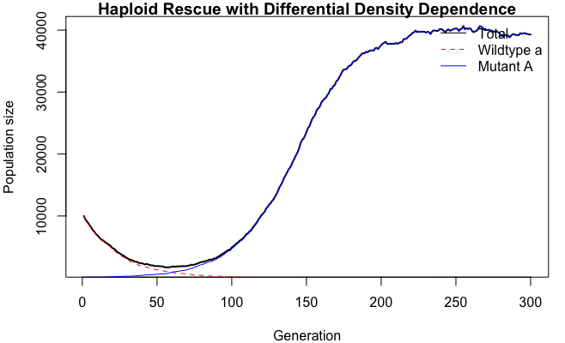 Figure 1

In this project I use a stochastic model of a haploid branching process to suggest principles of evolutionary rescue for a declining population under density-dependent regulation, through the introduction of better-adapted mutants.

1 Introduction
When an abrupt change in environment leads to a population becoming maladapted, it consequently suffers a demographic decline. If the population is able to recover from this bottleneck, evolutionary rescue occurs (Wilson et al. 2017). In today's changing climate, this subject is gaining growing attention.

In natural populations, bottlenecks happen, for example, because of environmental change, decreasing the fitness of the population; introduction of a better adapted mutant with a fitness advantage can lead to rescue of the population. In this report we define "rescue" as demographic recovery, whereby it is irrelevant which genotype the rescued population is comprised of in the end. This discrete-time model is highly simplistic with the haploid population being panmictic and of arbitrary size. This gives us a manageable null model where the rules for optimal rescue can be analyzed.

We explore a simple logistic model with a density sensitivity scaling factor f, whereby fitness advantage is density dependent. The simple computation of each life cycle proceeds as follows:
- The per-capita effective fitness is calculated for each phenotype following this logistic density-dependent formula for wildtype (a) and mutant (A) respectively.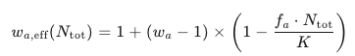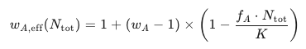
- Individuals reproduce randomly following the Poisson distribution, introducing stochasticity.
- The offspring replaces the parental generation and the simulation checks for extinction (N_tot < 1) or rescue (N_tot ≥ 0.5K).
Gamblin, Marrec, and Olazcuaga (2023) state that the impact of bottlenecks due to changing environment have mostly been experimentally tested on microbial populations and the application of these theoretical predictions on a macroscopic scale is rather limited. They identify density dependence as a critical but underexplored factor influencing evolutionary rescue. This leads us to include the realistic factor of density dependence in this microorganism-like framework where large populations reproduce rapidly.

According to Gamblin et al. (2023)state that an important concern during a bottleneck is genetic drift, so the question arises: at which size of the population should the mutant with the beneficial mutation but greater density sensitivity be introduced, balancing the heightened effect of genetic drift at lower numbers with its heightened density dependence at larger numbers? Additionally, the cost-effectiveness should be respected, also limiting the number of introduced mutants.
The central question is: what is the optimal fraction of the total population that should be introduced to ensure a rescue probability of 90 percent?

Early theoretical frameworks like Orr and Unckless (2008) also use a branching process model with the following similarities to my model: haploid population under weak selection with discrete generations and large populations with high carrying capacity. The main difference is they have density independent fitness. An interesting conclusion of theirs is that "absolute copy number of an allele, not its frequency, determines the probability of population survival" (p. 168). This raises the critical idea that larger populations have a disproportionate advantage: larger N₀ require a proportionally smaller mutant fraction to achieve the same rescue probability.
My findings confirm this copy number or head count rule holds, even with density dependence. Larger population sizes have disproportionate advantage: a 10 times larger N₀ gives roughly 10 times more mutants and thus around 10 times higher rescue probability, even though the mutant fraction stays the same. This suggests a scaling factor between starting population size and fraction of mutants introduced.
Three questions:
- What is the critical mutant fraction p₀* at a reference size N₀ = 10,000?
- How does p₀* scale with N₀, and does the slope support a head count rule?
- How does density feedback alter rescue probability?

2 Methods

2.1 Simulation framework
A haploid, discrete-generation branching process with density-dependent fitness was implemented using R 4.3.1. Every generation goes through two stages: (1) use a logistic density-dependence function to calculate the per-capita effective fitness of each genotype based on the total population size N_tot; (2) use independent Poisson sampling to produce offspring, where the mean for each genotype is equal to its parental count multiplied by its effective fitness. After reproduction, parents are removed, and the next generation is made up of the offspring. K = 50,000 scales the strength of density-dependent fitness reduction, which naturally controls growth, rather than explicitly capping population size at K. If N_tot is less than 1, extinction is declared. This framework mimics the life histories of rapidly reproducing organisms with distinct, non-overlapping generations, such as those found in experimental microbial evolution (e.g., serial passaging).

2.2 Fitness model
The logistic form of effective fitness was as follows:
w_eff(g, N_tot) = 1 + (w_g − 1) × (1 − f_g × N_tot / K), where f_g scales density feedback strength and w_g is genotype-specific intrinsic fitness. Intrinsic decline is ensured by wildtype parameters (w_a = 0.95, f_a = 1.0); fitness reaches w_eff = 1 at N_tot = K. The initial growth advantage provided by the mutant parameters diminishes as crowding increases. Per-capita growth for both genotypes collapses below 1 as N_tot → K, stabilizing the population. This formulation captures density-regulated growth; f_A = 1.25 was the default mutant sensitivity (w_eff(A, K) = 1 + (1.05 − 1)×(1 − 1.25) = 0.9875).

2.3 Experimental stages

Stage 1: Sweep the rescue probability across p₀ values.
A log-spaced grid of 20 values, ranging from 1/N₀ to 0.2, was used to vary the initial mutant fraction p₀. Up to 300 generations of 200 replicate simulations were run for each value. The 90% rescue threshold p₀* was determined as the smallest grid point where the empirical rescue probability met or exceeded 0.9. Rescue was defined as the total population reaching ≥ 0.5 K at any time.

Stage 2A: Scaling of rescue threshold with N₀.
N₀ = 200, 500, 1,000, 2,500, 5,000, 10,000, 20,000, and 40,000 were the eight initial population sizes that were tested. The same p₀ grid (25 log-spaced values) and 200 replicates per point as in Stage 1 were used to create the rescue-probability curve for each. For every N₀, the 90% rescue threshold p₀* was extracted, and the scaling exponent β was estimated using a log–log linear regression of p₀* against N₀. To test the constant-head-count hypothesis, the absolute mutant head-count N_mut* = p * × N₀ was calculated.
Stage 2B: Simple logistic density dependence
The fitness function was adjusted to the standard logistic form, using w_eff = 1 + (w − 1)(1 − N_tot/K) to remove the genotype-specific scaling factor f. All other parameters and steps matched Stage 2A We derived the absolute mutant requirement for each threshold N_mut* = p₀ * × N₀.

Stage 3: Sensitivity to density across p₀ values.
A rough sweep was conducted to change the initial mutant fraction p₀ and the crowding coefficient f_A in order to isolate the impact of mutant-specific density feedback. Eight values of the crowding coefficient (f_A = {0.5, 0.75, 1.0, 1.25, 1.5, 2.0, 2.5, 3.0}) were tested. Three fixed p₀ values were analyzed for each f_A: p₀ = 0.005 (below critical threshold), p₀ = 0.01 (near threshold), and p₀ = 0.02 (above threshold). Every combination of (f_A, p₀) was replicated 200 times. The percentage of replicates where the total population reached ≥ 0.5 K prior to extinction was used to calculate rescue probability. As a reference condition, the default parameter f_A = 1.25 was used.

Stage 4: Rebound dynamics
10 p₀ values across the critical threshold were simulated for 200 replicates using N₀ = 10,000. I noted the final result, the minimum population size prior to rebound, and the time it took to reach 0.5 K for each trajectory. This phase functioned as an additional visual representation of the dynamics rescue.

Results

3.1 Rescue curve and critical threshold
When N₀ = 10,000, the chance of rescue goes up quickly with p₀ (Fig. 2). The minimum initial mutant fraction required for 90% rescue is p₀* = 0.0037, equating to 37 mutants. If p₀ is less than 0.002, rescue is rare because most populations go extinct before mutants can establish. Rescue is almost certain when p₀ is greater than 0.01. The curve's shape shows that there is stochastic loss at low p₀ and saturation at high p₀.

Figure 2
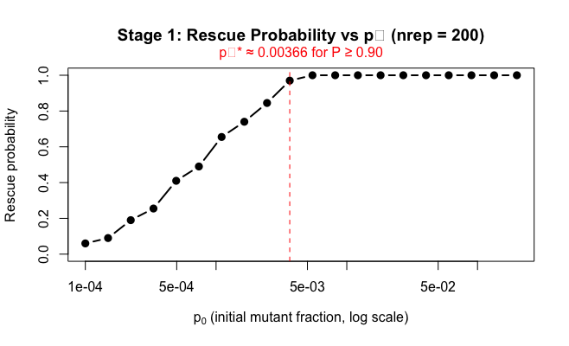

Scaling initial mutant fraction with population size
We used the same 25-point p₀ grid and 200 replicates per point as in Stage 1 to find p₀* for eight different starting population sizes (N₀ = 200, 500, 1,000, 2,500, 5,000, 10,000, 20,000, and 40,000). A log-log regression of p₀* versus N₀ produced a slope of -1.33 (Fig. 3A), establishing the scaling relationship p₀* ∝ N₀⁻¹·³³. So, the absolute number of mutant heads, N_mut* = p₀* × N₀, stayed around 28 individuals for all N₀ (Fig. 3A). This shows that rescue depends on the absolute number, not the fraction. At N₀ = 10,000, this equals p₀* = 0.0037, which is the same as the Stage 1 threshold.
As seen in Figure 3B under simple logistic density dependence, the scaling exponent was β = −1.36. The absolute mutant requirement N₀ × p₀* was about 28 across population sizes.

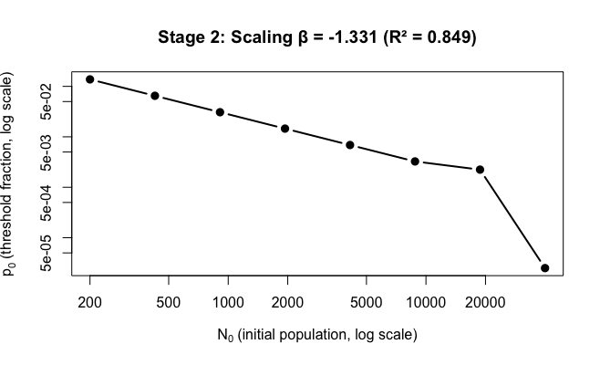 Figure 3A
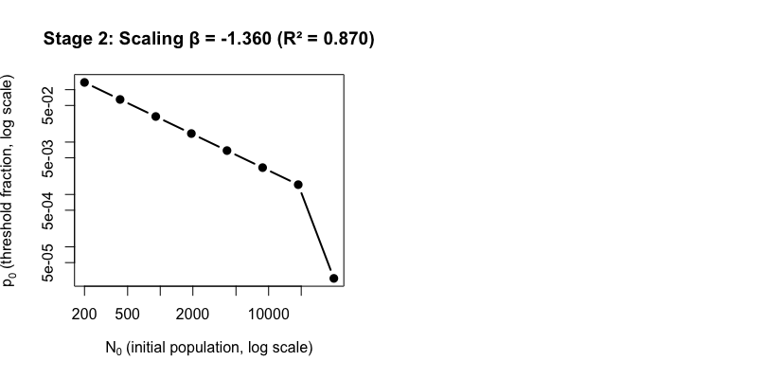 Figure 3B

Crowding sensitivity
The probability of rescue stayed at 100% for all three p₀ values (0.005, 0.01, and 0.02) until f_A went over about 2.0. After that, it dropped quickly toward zero (Fig. 4). This threshold-like behavior shows that the mutant's natural advantage (w_A = 1.05) can only make up for the costs of crowding up to f_A ≈ 2.0; after that, density sensitivity takes over the mutant no matter what the initial fraction is. The default f_A = 1.25 is well below this important crowding limit.

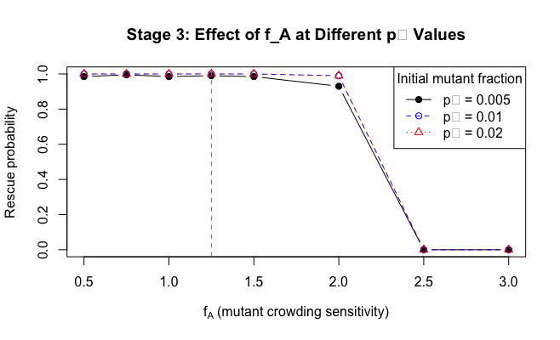 Figure 4

3.4 Rebound dynamics
Populations that are close to the rescue threshold show a typical dip before they grow. As p₀ increase, the time it takes to rebound goes down, and the minimum population size during the dip goes up. At p₀ = 0.001, most copies die out. Figure 5 shows this pattern by showing the median rebound time and minimum size across 200 replicates.
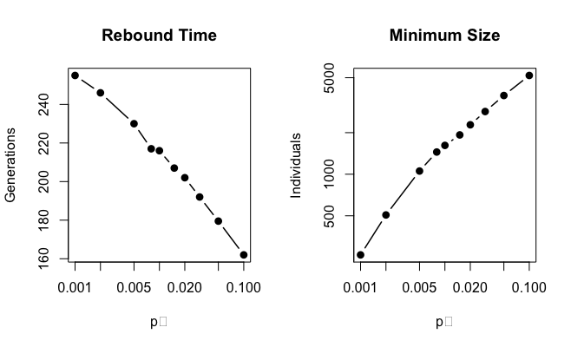 Figure 5A
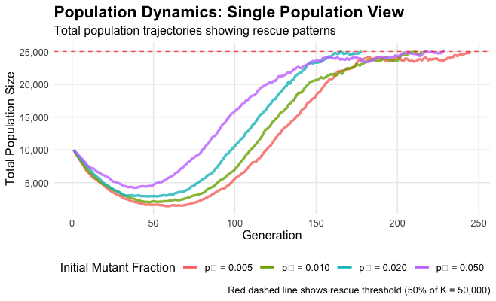 Figure 5B

4 Discussion

4.1 Scaling and the headcount rule
The simulations show that the chance of rescue depends on the total number of mutants, not the fraction. Stage 2 shows that p₀* scales as N₀⁻¹·³³, which is steeper than I expected. However, the product N₀ × p₀* stays close to 28 across two orders of magnitude in N₀. This head-count rule could arise because demographic stochasticity gets weaker in large populations (which lowers per-copy loss) and density dependence lowers mutant fitness when N_tot is high (which lowers per-copy advantage). The net effect is that about 28 mutants are enough, no matter if N₀ is 1,000 or 40,000. In practice, this means that conservation managers should count individuals introduced instead of percentages. For example, releasing 0.1% of a large population may not be enough, while the same fraction in a small population may be too much, also reducing cost effectiveness. Notably it should be noted that in stage 2B when the mutant’s density-dependence scaling factor of f_A=1.25, was removed, the head-count rule was maintained but the scaling factor was even slightly heightened. So, the density dependence scaling factor only minimally alters how p₀* scales as N₀, with -1.36 being the exponent. However, this should further be investigated by testing the scaling factor across a range f_A’s.

4.2 Crowding sensitivity
Stage 3 shows a clear crowding threshold: when f_A > 2.0, rescue fails no matter what p₀ is. Crowding has a small effect below this threshold, but above it, the mutant's natural advantage can't compete with the costs of density. In our baseline parameter set, the head-count rule works well because the default value of f_A = 1.25 is well below this limit. In real life, this means that managers need to figure out how competitive the target species is (f_A) before they can set the release size. If a mutant that does well in low-density lab conditions, but one is not careful about how sensitive it is to crowding it may not do well in the field.

5 Conclusion

These simulations generalize the Orr & Unckless copy-number principle to density-regulated systems. The head-count rule remains relevant: rescue scales with absolute mutants, not frequency. The connection between density feedback and the scaling exponent has to be investigated further, but at this point, the density sensitivity does not seem to have a significant influence. A crowding threshold (f_A ≈ 2.0) limits rescue possibility regardless of the starting numbers.

Practically, this translates to the idea that release strategies should be head counts rather than percentages: introducing ≥28 mutants gives us a 90% robust rescue probability. The haploid, single-locus model was drastically simplified, but the fundamental concept still gives us reference point for conservation applications.

References
- Gamblin, J., Marrec, L. & Olazcuaga, L. (2023). How bottlenecks shape adaptive potential: from theory and microbiology to conservation biology. https://doi.org/10.32942/X2M608
  - (this is a preprint)

- Orr HA, Unckless RL. Population extinction and the genetics of adaptation. Am Nat. 2008 Aug;172(2):160-9. doi: 10.1086/589460. PMID: 18662122.

- Benjamin A Wilson, Pleuni S Pennings, Dmitri A Petrov, Soft Selective Sweeps in Evolutionary Rescue, Genetics, Volume 205, Issue 4, 1 April 2017, Pages 1573–1586, https://doi.org/10.1534/genetics.116.191478

- Jasmine Gamblin, Sylvain Gandon, François Blanquart, Amaury Lambert, Bottlenecks can constrain and channel evolutionary paths, Genetics, Volume 224, Issue 2, June 2023, iyad001, https://doi.org/10.1093/genetics/iyad001

Figures
- Figure 1: Base population trajectory rescue plot
- Figure 2: Rescue probability vs. initial mutant fraction p0
- Figure 3A: Scaling initial mutant fraction with population size
- Figure 3B: Scaling initial mutant fraction with population size, without f_A
- Figure 4: Effect of density dependence at different p0 values
- Figure 5A: Rebound dynamics: Rebound time and minimum size
- Figure 5B: Rebound dynamics: Population trajectories showing rescue patterns

